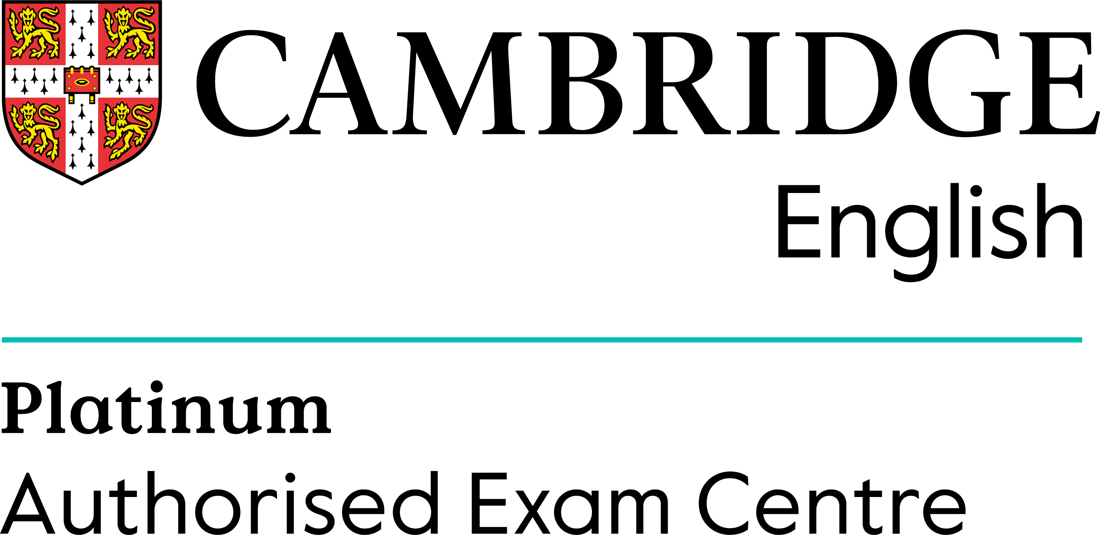

International House Milan & Cambridge English
are pleased to invite you to our seminar:
at IIS TORRIANI
Via Seminario, 19 – Cremona

PRACTICAL IDEAS FOR TEACHING AND ASSESSING SPEAKING FOR B2 FIRST
22nd February 2023

Timetable

14:30 | Registration
14:45 | WELCOME AND BRIEF SUMMARY OF SPEAKING SEMINAR
15:00 | PRACTICAL IDEAS FOR TEACHING AND ASSESSING SPEAKING FOR B2 FIRST PART 1 – NINO  NASO INTERNATIONAL HOUSE MILAN
16:15 | Refreshments
16:30 | PRACTICAL IDEAS FOR TEACHING AND ASSESSING SPEAKING FOR B2 FIRST PART 2 – NINO NASO INTERNATIONAL HOUSE MILAN
18:00 | Certificates

Partecipazione gratuita fino ad esaurimento posti
Per informazioni:
International House: Tel. 02 5279124 - esamicambridge@ihmilano.it www.ihmilano.it

SCANSIONA QUI PER REGISTRARTI
